Q1. Write a Dart program to calculate the sum of two numbers entered by the user.
import 'dart:io';

void main() {
print("Enter first number:");
var a = double.parse(stdin.readLineSync()!);

print("Enter second number:");
var b = double.parse(stdin.readLineSync()!);

print("Sum = ${a + b}");
}

Q2. Implement a Dart program that uses if-else statements to determine if a number is odd or even.

import 'dart:io';

void main() {
print("Enter a number:");
int num = int.parse(stdin.readLineSync()!);

if (num % 2 == 0) {
print("The number is Even");
} else {
print("The number is Odd");
}
}

Q3) Demonstrate the use of a switch-case statement in Dart.

void main() { int num = 2;

switch (num) { case 1: print("One"); break; case 2: print("Two"); break; default:
print("Other number");
}
}

Q4) Write a program to print a multiplication table using a for loop.

import 'dart:io';

void main() {
print("Enter a number:"); int num = int.parse(stdin.readLineSync()!);

print("Multiplication Table of $num:");

for (int i = 1; i <= 10; i++) { int result = num * i; print("$num x $i = $result");
}
}

Q5) Create an Android application to design screens using different UI Elements like: Button, Edittext, Textview, Radio Button etc

<?xml version="1.0" encoding="utf-8"?>
<LinearLayout
xmlns:android="http://schemas.android.com/apk/res/android" xmlns:tools="http://schemas.android.com/tools" xmlns:app="http://schemas.android.com/apk/res-auto" android:id="@+id/main" android:layout_width="match_parent" android:layout_height="match_parent" android:orientation="vertical">

<EditText
android:layout_width="match_parent" android:layout_height="wrap_content" android:id="@+id/TO" android:hint="To"/>

<TextView
android:layout_width="match_parent" android:layout_height="wrap_content" android:text="User Name" android:hint="User Name"/>

<RadioButton
android:layout_width="150dp" android:layout_height="50dp" android:id="@+id/Male" android:text="Male"/> <RadioButton android:layout_width="150dp" android:layout_height="50dp" android:id="@+id/Female" android:text="Female"/>

<Button android:layout_width="150dp" android:layout_height="50dp" android:id="@+id/Submit" android:text="Submit"/>

</LinearLayout>

Q6) Create an Android application to demonstrate style and style inheritance.
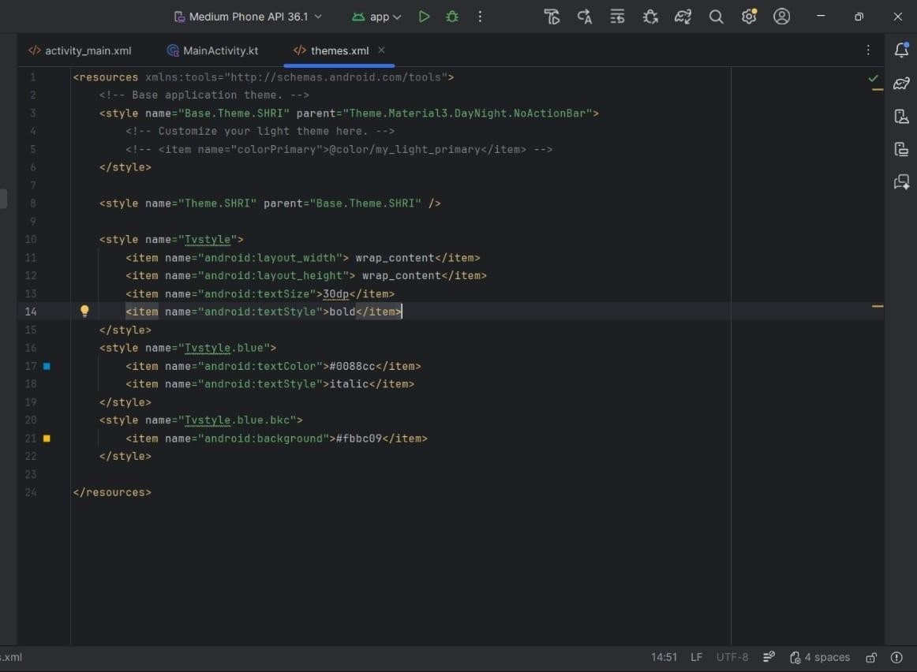
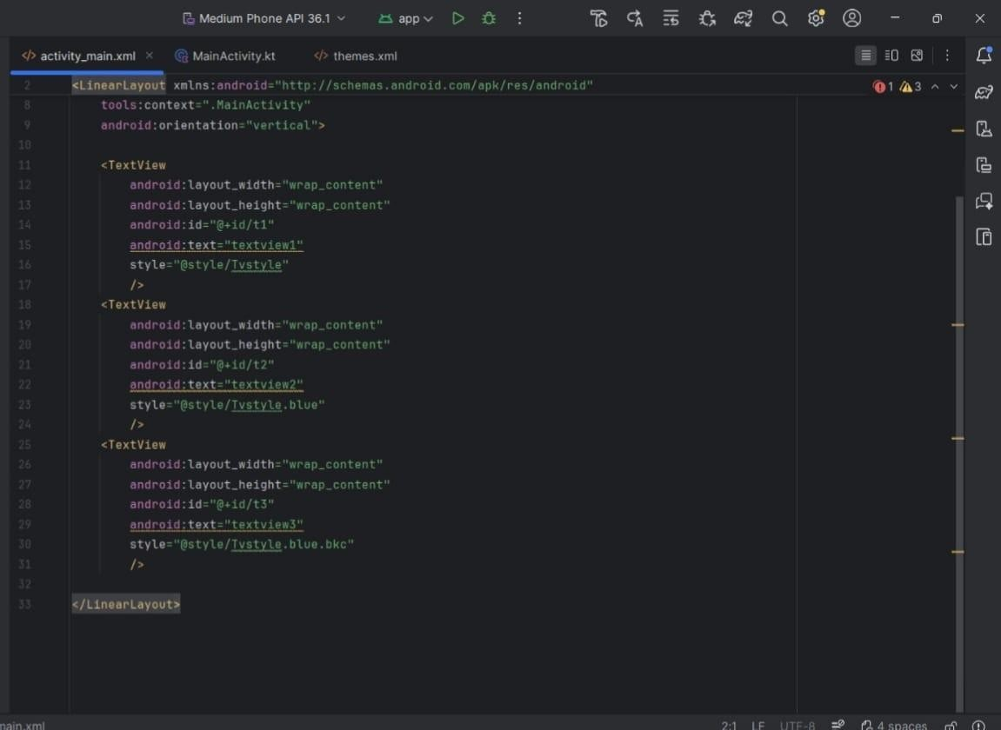

Q7) Create an Android application to design screens using Linear Layout.

<?xml version="1.0" encoding="utf-8"?>
<LinearLayout xmlns:android="http://schemas.android.com/apk/res/android" xmlns:app="http://schemas.android.com/apk/res-auto" xmlns:tools="http://schemas.android.com/tools" android:layout_width="match_parent" android:layout_height="match_parent" android:paddingLeft="20dp" android:paddingRight="20dp"
android:orientation="vertical">

<EditText android:layout_width="match_parent" android:layout_height="wrap_content" android:id="@+id/txtTo" android:hint="To"/>
<EditText android:layout_width="match_parent" android:layout_height="wrap_content" android:id="@+id/txtSub" android:hint="SUbject"/>
<EditText android:layout_width="match_parent" android:layout_height="0dp" android:layout_weight="1" android:id="@+id/txtMsg" android:gravity="top" android:hint="Message"/>
<Button android:layout_width="100dp" android:layout_height="wrap_content" android:layout_gravity="right" android:text="Send"/>
</LinearLayout>

Q8) Create an Android application to design screens using Relative Layout.

<?xml version="1.0" encoding="utf-8"?>
<RelativeLayout xmlns:android="http://schemas.android.com/apk/res/android" xmlns:app="http://schemas.android.com/apk/res-auto" xmlns:tools="http://schemas.android.com/tools" android:layout_width="fill_parent" android:layout_height="fill_parent">

<Button
android:id="@+id/button1" android:layout_width="wrap_content" android:layout_height="wrap_content" android:layout_alignParentLeft="true" android:layout_alignParentTop="true" android:text="Top Left Button" />

<Button
android:layout_width="wrap_content" android:layout_height="wrap_content" android:id="@+id/button2" android:text="Top Right Button" android:layout_alignParentRight="true" android:layout_alignParentTop="true"/>
<Button
android:layout_width="wrap_content" android:layout_height="wrap_content" android:id="@+id/button3" android:text="Bottom Left Button" android:layout_alignParentLeft="true" android:layout_alignParentBottom="true"/>
<Button
android:layout_width="wrap_content" android:layout_height="wrap_content" android:id="@+id/button4" android:text="Bottom Right Button" android:layout_alignParentRight="true" android:layout_alignParentBottom="true"/>
<Button
android:layout_width="fill_parent" android:layout_height="wrap_content" android:id="@+id/button5" android:text="Middle Button" android:layout_centerVertical="true" android:layout_centerHorizontal="true"/>
</RelativeLayout>

Q9) Create an Android application to design screens using Table Layout.

<?xml version="1.0" encoding="utf-8"?>
<TableLayout xmlns:android="http://schemas.android.com/apk/res/android" xmlns:app="http://schemas.android.com/apk/res-auto" xmlns:tools="http://schemas.android.com/tools" android:layout_width="match_parent" android:layout_height="match_parent" android:layout_marginTop="100dp" android:paddingLeft="10dp" android:paddingRight="10dp">
<TableRow> <TextView
android:layout_width="wrap_content" android:layout_height="wrap_content" android:layout_weight="1" android:text="UserID"/>
<TextView
android:layout_width="wrap_content" android:layout_height="wrap_content" android:layout_weight="1" android:text="User Name"/>
<TextView
android:layout_width="wrap_content" android:layout_height="wrap_content" android:layout_weight="1" android:text="Location"/>

</TableRow>
<TableRow> <TextView
android:layout_width="wrap_content" android:layout_height="wrap_content" android:layout_weight="1" android:text="1"/> <TextView
android:layout_width="wrap_content" android:layout_height="wrap_content" android:layout_weight="1" android:text="Hemangi padhiyar"/>
<TextView
android:layout_width="wrap_content" android:layout_height="wrap_content" android:layout_weight="1" android:text="Mumbai"/>

</TableRow>
<TableRow> <TextView
android:layout_width="wrap_content" android:layout_height="wrap_content" android:layout_weight="1" android:text="2"/> <TextView
android:layout_width="wrap_content" android:layout_height="wrap_content" android:layout_weight="1" android:text="Siddhi Shinde"/>
<TextView
android:layout_width="wrap_content" android:layout_height="wrap_content" android:layout_weight="1" android:text="Pune"/>
</TableRow>

</TableLayout>

Q10) Create an Android application to design screens using Absolute Layout.

<?xml version="1.0" encoding="utf-8"?>
<AbsoluteLayout xmlns:android="http://schemas.android.com/apk/res/android" xmlns:app="http://schemas.android.com/apk/res-auto" xmlns:tools="http://schemas.android.com/tools" android:layout_width="fill_parent" android:layout_height="fill_parent">

<Button
android:layout_width="100dp" android:layout_height="wrap_content" android:text="OK" android:layout_x="50px" android:layout_y="361px"/>
<Button
android:layout_width="100dp" android:layout_height="wrap_content" android:text="Cancel" android:layout_x="225px" android:layout_y="361px"

</AbsoluteLayout>

Q11) Create an Android application to design screens using Frame Layout.

<?xml version="1.0" encoding="utf-8"?>
<FrameLayout xmlns:android="http://schemas.android.com/apk/res/android" xmlns:app="http://schemas.android.com/apk/res-auto" xmlns:tools="http://schemas.android.com/tools" android:layout_width="match_parent" android:layout_height="match_parent" android:orientation="vertical">
<ImageView
android:layout_width="wrap_content" android:layout_height="wrap_content" android:id="@+id/img1" android:scaleType="centerCrop" android:src="@mipmap/f1"/>
<TextView
android:layout_width="match_parent" android:layout_height="wrap_content" android:id="@+id/txt1" android:layout_marginTop="40dp" android:padding="10dp" android:text="Rose" android:textSize="20sp"/>
<TextView
android:layout_width="wrap_content" android:layout_height="wrap_content" android:padding="10dp" android:layout_gravity="right|bottom" android:text="02/feb/2026" android:textSize="18sp"/>

</FrameLayout>
Q12) Create an Android application to demonstrate implicit and explicit intents.
</>Main_Activity.xml

<?xml version="1.0" encoding="utf-8"?>
<LinearLayout xmlns:android="http://schemas.android.com/apk/res/android" xmlns:app="http://schemas.android.com/apk/res-auto" xmlns:tools="http://schemas.android.com/tools" android:layout_width="match_parent" android:layout_height="match_parent" android:orientation="vertical">

<EditText
android:layout_width="wrap_content" android:layout_height="wrap_content" android:text="Enter URL Here" android:id="@+id/url"/>
<Button
android:layout_width="wrap_content" android:layout_height="wrap_content" android:id="@+id/search" android:text="Search"/>
<Button
android:layout_width="wrap_content" android:layout_height="wrap_content" android:id="@+id/hello" android:text="Click for Hello"/>

</LinearLayout>

AndroiidMainfest.xml

<?xml version="1.0" encoding="utf-8"?>
<manifest xmlns:android="http://schemas.android.com/apk/res/android" xmlns:tools="http://schemas.android.com/tools">

<application
android:allowBackup="true"
android:dataExtractionRules="@xml/data_extraction_rules" android:fullBackupContent="@xml/backup_rules" android:icon="@mipmap/ic_launcher" android:label="@string/app_name" android:roundIcon="@mipmap/ic_launcher_round" android:supportsRtl="true"
android:theme="@style/Theme.IntentExample">
<activity
android:name=".MainActivity" android:exported="true" android:label="intentExample"
android:theme="@style/Theme.IntentExample">
<intent-filter>
<action android:name="android.intent.action.MAIN" />

<category android:name="android.intent.category.LAUNCHER" />
</intent-filter>
</activity>
<activity android:name="HelloActivity" android:label="intentExample">

</activity>
</application>

</manifest>

MainActivity.kt

package com.example.myapplication

import android.content.Intent import android.os.Bundle import android.widget.Button import android.widget.EditText import androidx.activity.enableEdgeToEdge import androidx.appcompat.app.AppCompatActivity import androidx.core.view.ViewCompat import androidx.core.view.WindowInsetsCompat import java.net.URL

class MainActivity : AppCompatActivity() { lateinit var url: EditText lateinit var search: Button lateinit var hello: Button
override fun onCreate(savedInstanceState: Bundle?) { super.onCreate(savedInstanceState) enableEdgeToEdge()
setContentView(R.layout.activity_main)

url=findViewById(R.id.url) search=findViewById(R.id.search) hello=findViewById(hello)

search.setOnClickListener { val url = url.text.toString()
val urlIntent = Intent(Intent.ACTION_VIEW, uri.parse(url)) startActivity(urlIntent)

}

hello.setOnClickListener {
val i = Intent(applicationContext,HelloActivity::class.java) startActivity(i)
}
}
}
}

HelloActivity.kt

package com.example.intentexample

import android.os.Bundle
import androidx.activity.componentActivity import com.example.myapplication.R import kotlinx.coroutines.selects.SelectInstance

class HelloActivity : componentActivity() { override fun onCreate(savedInstanceState : Bundle? ) { super.onCreate(savedInstanceState) setContentView(R.layout.hello)
}
}

hello.xml

<?xml version="1.0" encoding="utf-8"?>
<LinearLayout xmlns:android="http://schemas.android.com/apk/res/android" android:layout_width="match_parent" android:layout_height="match_parent" android:orientation="vertical">

<EditText
android:layout_width="match_parent" android:layout_height="wrap_content" android:id="@+id/editTextText" android:ems="10" android:inputType="text" android:text="Hellooooo"/>

</LinearLayout>

Q13) Write an android application demonstrating response to event/user interaction for
- Checkbox
- Radio button
- Button
- Spinner

<?xml version="1.0" encoding="utf-8"?>
<TableLayout xmlns:android="http://schemas.android.com/apk/res/android" xmlns:app="http://schemas.android.com/apk/res-auto" xmlns:tools="http://schemas.android.com/tools" android:layout_width="match_parent" android:layout_height="match_parent" android:orientation="vertical">

<TableRow>
<EditText
android:id="@+id/Hobby" android:layout_width="100dp" android:layout_height="100dp" android:text="Hobby"/>
<CheckBox
android:id="@+id/Read" android:layout_width="150dp" android:layout_height="50dp" android:text="Read"/>
<CheckBox
android:id="@+id/Play" android:layout_width="150dp" android:layout_height="50dp" android:text="Play"/>

</TableRow>
<TableRow>
<EditText
android:id="@+id/Gender" android:layout_width="100dp" android:layout_height="100dp" android:text="Gender"/>

<RadioGroup> android:layout_width="wrap_content" android:layout_height="wrap_content"
<RadioButton android:id="@+id/Male" android:layout_width="150dp" android:layout_height="50dp" android:text="Male"/>

<RadioButton android:id="@+id/Female" android:layout_width="150dp" android:layout_height="50dp" android:text="female"/>
</RadioGroup>
</TableRow>
<TableRow>
<EditText android:id="@+id/State" android:layout_width="100dp" android:layout_height="100dp" android:text="State"/> <Spinner android:id="@+id/Spinner" android:layout_width="150dp" android:layout_height="50dp" android:spinnerMode="dialog" android:layout_marginBottom="8dp" android:layout_marginEnd="8dp" android:layout_marginStart="8dp" android:layout_marginTop="8dp"
</TableRow>
</TableLayout>

Q14) Create an Android application to demonstrate AutocompleteTextView and its working.

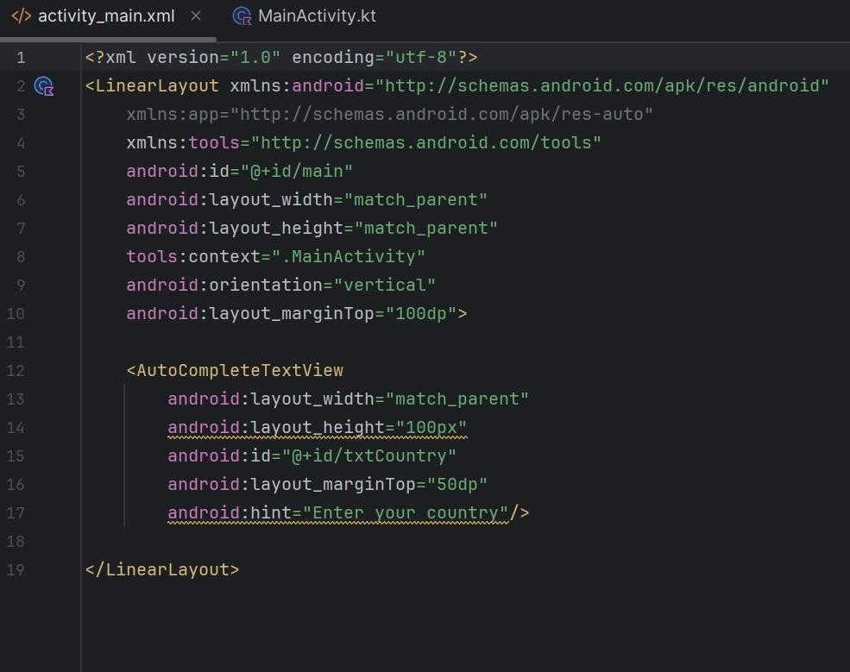

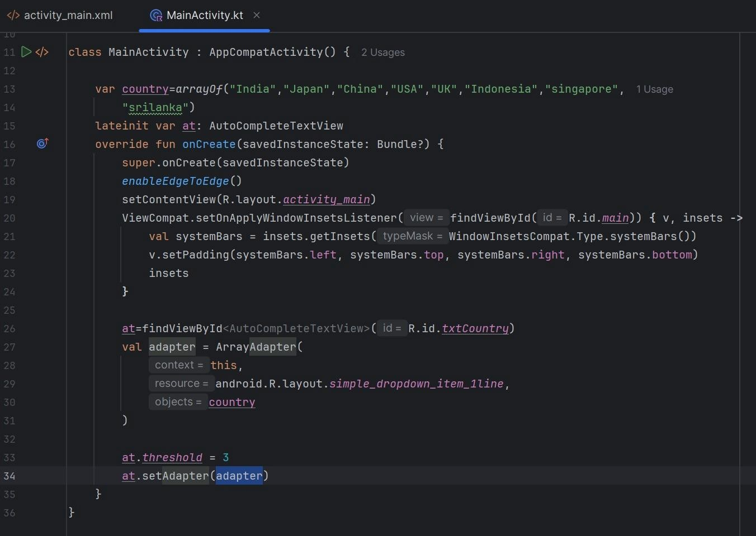

Q15) Create an Android application for Spinner and ProgressBar.

<?xml version="1.0" encoding="utf-8"?> <androidx.constraintlayout.widget.ConstraintLayout xmlns:android="http://schemas.android.com/apk/res/android" xmlns:tools="http://schemas.android.com/tools" xmlns:app="http://schemas.android.com/apk/res-auto" android:id="@+id/main" android:layout_width="match_parent" android:layout_height="match_parent" tools:context=".MainActivity">

<Spinner
android:id="@+id/coursesspinner" android:layout_height="50dp" android:layout_width="160dp" android:layout_marginEnd="10dp" android:layout_marginStart="10dp" android:layout_marginBottom="10dp" android:layout_marginTop="10dp" app:layout_constraintStart_toStartOf="parent" app:layout_constraintTop_toTopOf="parent"/>

</androidx.constraintlayout.widget.ConstraintLayout>

